Internet
Internet is defined to access information over the web. However, it can be defined in many ways as follows:
- Internet is a world-wide global system of interconnected computer networks.
- Internet uses the standard Internet Protocol (TCP/IP).
- Every computer in internet is identified by a unique IP address.
- IP Address is a unique set of numbers (such as 110.22.33.114) which identifies a computer location.
- A special computer DNS (Domain Name Server) is used to give name to the IP Address so that user can locate a computer by a name.
- For example, a DNS server will resolve a name http://www.tutorialspoint.com to a particular IP address to uniquely identify the computer on which this website is hosted.
- Internet is accessible to every user all over the world.
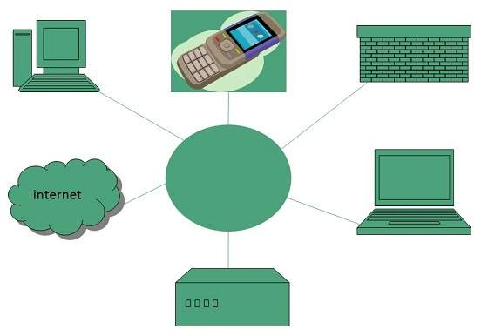

Evolution
The concept of Internet was originated in 1969 and has undergone several technological & Infrastructural changes as discussed below:
- The origin of Internet devised from the concept of Advanced Research Project Agency Network (ARPANET).
- ARPANET was developed by United States Department of Defense.
- Basic purpose of ARPANET was to provide communication among the various bodies of government.
- Initially, there were only four nodes, formally called Hosts.
- In 1972, the ARPANET spread over the globe with 23 nodes located at different countries and thus became known as Internet.
- By the time, with invention of new technologies such as TCP/IP protocols, DNS, WWW, browsers, scripting languages etc.,Internet provided a medium to publish and access information over the web.

Architecture of the Internet

Important Terms
❐ POP (Point of Presence): an access point to the Internet. It is a physical location that houses servers, routers, ATM switches and digital/analog call
aggregators
❐ ISP (Internet Service Provider): business or organization that provides consumers or businesses access to the Internet and related services
❐ Backbone: a large collection of interconnected commercial, government, academic and other high capacity data routes and core routers that carry data
across the countries, continents and oceans of the world
❐ NAP (Network Access Point): 4 Network access points where a packet switches from one backbone to another.
Network Application
Some from e-commerce

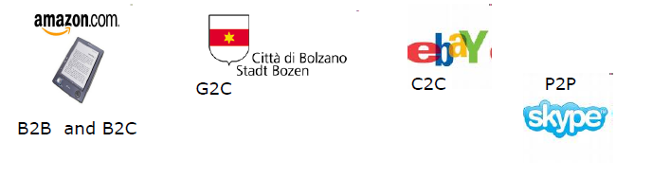

Advantages
Internet covers almost every aspect of life, one can think of. Here, we will discuss some of the advantages of Internet:
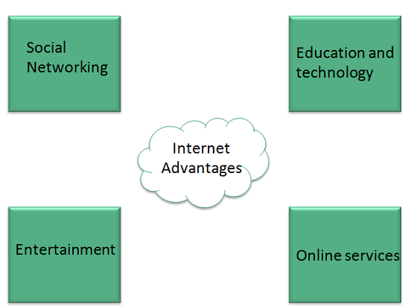
- Internet allows us to communicate with the people sitting at remote locations. There are various apps available on the wed that uses Internet as a medium for communication. One can find various social networking sites such as:
  - Facebook
  - Twitter
  - Yahoo
  - Google+
  - Flickr
  - Orkut
- One can surf for any kind of information over the internet. Information regarding various topics such as Technology, Health & Science, Social Studies, Geographical Information, Information Technology, Products etc can be surfed with help of a search engine.
- Apart from communication and source of information, internet also serves a medium for entertainment. Following are the various modes for entertainment over internet.
  - Online Television
  - Online Games
  - Songs
  - Videos
  - Social Networking Apps
- Internet allows us to use many services like:
  - Internet Banking
  - Matrimonial Services
  - Online Shopping
  - Online Ticket Booking
  - Online Bill Payment
  - Data Sharing
  - E-mail
- Internet provides concept of electronic commerce, that allows the business deals to be conducted on electronic systems

Disadvantages
However, Internet has prooved to be a powerful source of information in almost every field, yet there exists many disadvantages discussed below:
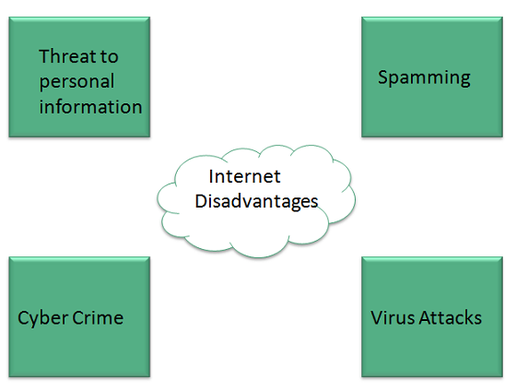
- There are always chances to loose personal information such as name, address, credit card number. Therefore, one should be very careful while sharing such information. One should use credit cards only through authenticated sites.
- Another disadvantage is the Spamming. Spamming corresponds to the unwanted e-mails in bulk. These e-mails serve no purpose and lead to obstruction of entire system.
- Virus can easily be spread to the computers connected to internet. Such virus attacks may cause your system to crash or your important data may get deleted.
- Also a biggest threat on internet is pornography. There are many pornographic sites that can be found, letting your children to use internet which indirectly affects the children healthy mental life.
- There are various websites that do not provide the authenticated information. This leads to misconception among many people.
- Internet Services allows us to access huge amount of information such as text, graphics, sound and software over the internet. Following diagram shows the four different categories of Internet Services.
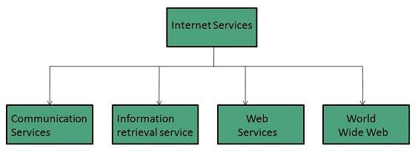

Communication Services
- There are various Communication Services available that offer exchange of information with individuals or groups. The following table gives a brief introduction to these services:
S.N. | Service Description
1 | Electronic Mail  Used to send electronic message over the internet.
2 | Telnet  Used to log on to a remote computer that is attached to internet.
3 | Newsgroup  Offers a forum for people to discuss topics of common interests.
4 | Internet Relay Chat (IRC)  Allows the people from all over the world to communicate in real time.
5 | Mailing Lists  Used to organize group of internet users to share common information through e-mail.
6 | Internet Telephony (VoIP)  Allows the internet users to talk across internet to any PC equipped to receive the call.
7 | Instant Messaging  Offers real time chat between individuals and group of people. Eg. Yahoo messenger, MSN messenger.

Information Retrieval Services
- There exist several Information retrieval services offering easy access to information present on the internet. The following table gives a brief introduction to these services:
S.N. | Service Description
1 | File Transfer Protocol (FTP)  Enable the users to transfer files.
2 | Archie  It’s updated database of public FTP sites and their content. It helps to search a file by its name.
3 | Gopher  Used to search, retrieve, and display documents on remote sites.
4 | Very Easy Rodent Oriented Netwide Index to Computer Achieved (VERONICA)  VERONICA is gopher based resource. It allows access to the information resource stored on gopher’s servers.

Web Services
- Web services allow exchange of information between applications on the web. Using web services, applications can easily interact with each other.
- The web services are offered using concept of Utility Computing.

World Wide Web (WWW)
- WWW is also known as W3. It offers a way to access documents spread over the several servers over the internet. These documents may contain texts, graphics, audio, video, hyperlinks. The hyperlinks allow the users to navigate between the documents.

Video Conferencing
- Video conferencing or Video teleconferencing is a method of communicating by two-way video and audio transmission with help of telecommunication technologies.

Modes of Video Conferencing

Point-to-Point
- This mode of conferencing connects two locations only.
- 

Multi-point
- This mode of conferencing connects more than two locations through Multi-point Control Unit (MCU).
- 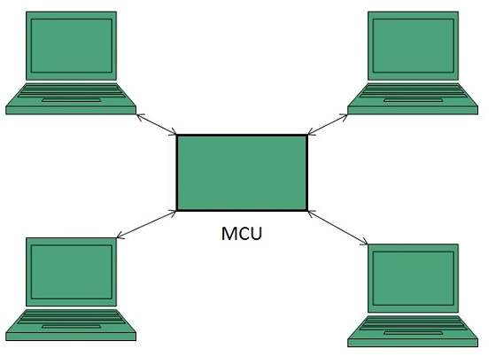

Here in this tutorial, we will discuss how to connect to internet i.e. internet service providers, software and hardware requirements, configuring internet connection etc.

Internet Service Providers (ISP)
Internet Service Provider (ISP) is a company offering access to internet. They offer various services:
- Internet Access
- Domain name registration
- Dial-up access
- Leased line access

ISP Types
ISPs can broadly be classified into six categories as shown in the following diagram:
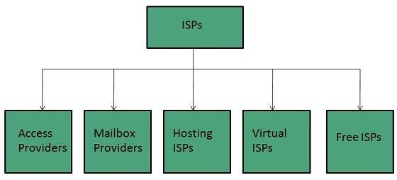

Access providers
They provide access to internet through telephone lines, cable wi-fi or fiber optics.

Mailbox Provider
Such providers offer mailbox hosting services.

Hosting ISPs
Hosting ISPs offers e-mail, and other web hosting services such as virtual machines, clouds etc.

Virtual ISPs
Such ISPs offer internet access via other ISP services.

Free ISPs
Free ISPs do not charge for internet services.

Connection Types
There exist several ways to connect to the internet. Following are these connection types available:
- Dial-up Connection
- ISDN
- DSL
- Cable TV Internet connections
- Satellite Internet connections
- Wireless Internet Connections

Dial-up Connection
Dial-up connection uses telephone line to connect PC to the internet. It requires a modem to setup dial-up connection. This modem works as an interface between PC and the telephone line.
There is also a communication program that instructs the modem to make a call to specific number provided by an ISP.
Dial-up connection uses either of the following protocols:
- Serial Line Internet Protocol (SLIP)
- Point to Point Protocol (PPP)
The following diagram shows the accessing internet using modem:
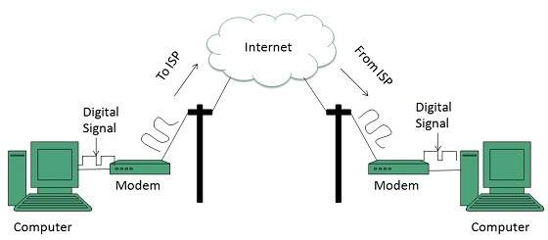

ISDN
ISDN is acronym of Integrated Services Digital Network. It establishes the connection using the phone lines which carry digital signals instead of analog signals.
There are two techniques to deliver ISDN services:
- Basic Rate Interface (BRI)
- Primary Rate Interface (PRI)
Key points:
- The BRI ISDN consists of three distinct channels on a single ISDN line: t1o 64kbps B (Bearer) channel and one 16kbps D (Delta or Data) channels.
- The PRI ISDN consists of 23 B channels and one D channels with both have operating capacity of 64kbps individually making a total transmission rate of 1.54Mbps.
The following diagram shows accessing internet using ISDN connection:
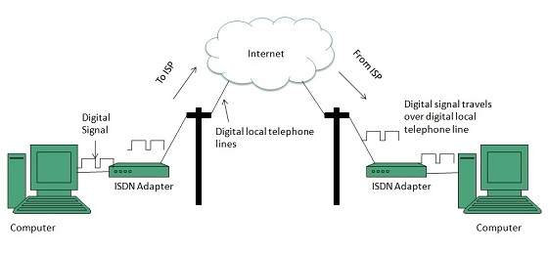

DSL
DSL is acronym of Digital Subscriber Line. It is a form of broadband connection as it provides connection over ordinary telephone lines.
Following are the several versions of DSL technique available today:
- Asymmetric DSL (ADSL)
- Symmetric DSL (SDSL)
- High bit-rate DSL (HDSL)
- Rate adaptive DSL (RDSL)
- Very high bit-rate DSL (VDSL)
- ISDN DSL (IDSL)
All of the above mentioned technologies differ in their upload and download speed, bit transfer rate and level of service.
The following diagram shows that how we can connect to internet using DSL technology:
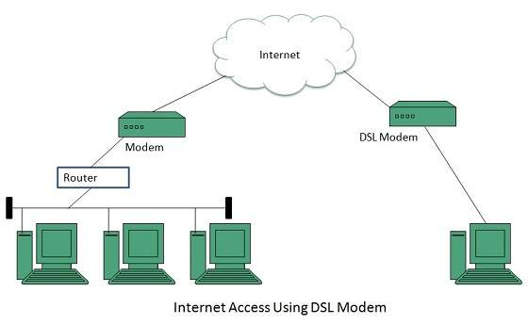

Cable TV Internet Connection
Cable TV Internet connection is provided through Cable TV lines. It uses coaxial cable which is capable of transferring data at much higher speed than common telephone line.
Key Points:
- A cable modem is used to access this service, provided by the cable operator.
- The Cable modem comprises of two connections: one for internet service and other for Cable TV signals.
- Since Cable TV internet connections share a set amount of bandwidth with a group of customers, therefore, data transfer rate also depends on number of customers using the internet at the same time.
The following diagram shows that how internet is accessed using Cable TV connection:
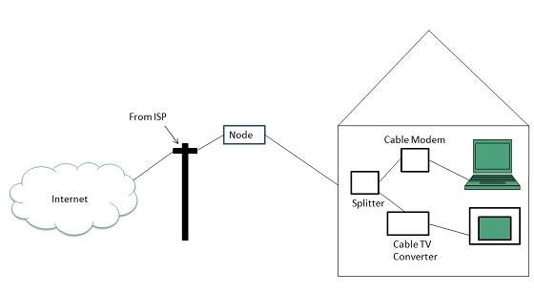

Satellite Internet Connection
Satellite Internet connection offers high speed connection to the internet. There are two types of satellite internet connection: one way connection or two way connection.
In one way connection, we can only download data but if we want to upload, we need a dialup access through ISP over telephone line.
In two way connection, we can download and upload the data by the satellite. It does not require any dialup connection.
The following diagram shows how internet is accessed using satellite internet connection:
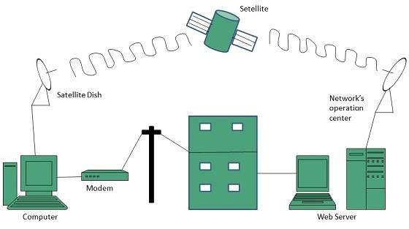

Wireless Internet Connection
Wireless Internet Connection makes use of radio frequency bands to connect to the internet and offers a very high speed. The wireless internet connection can be obtained by either WiFi or Bluetooth.
Key Points:
- Wi Fi wireless technology is based on IEEE 802.11 standards which allow the electronic device to connect to the internet.
- Bluetooth wireless technology makes use of short-wavelength radio waves and helps to create personal area network (PAN).

